Steps to add translation to a youtube video

1. Login to youtube
2. Select a video you want add translation to
3. Click three dots and select ‘add translations’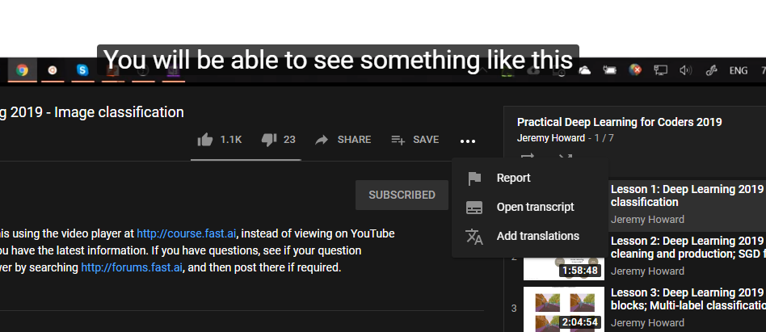
4. Click on `Switch language’ and select language you want to add translation for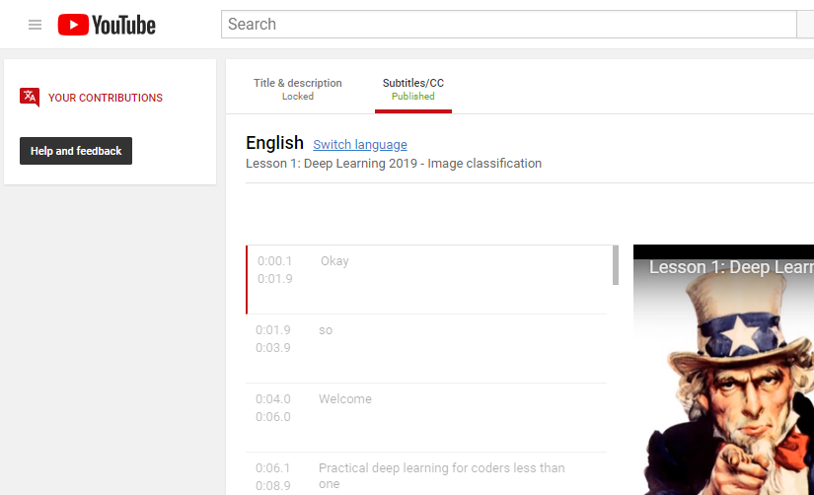
5. Autotranslate is a good starting point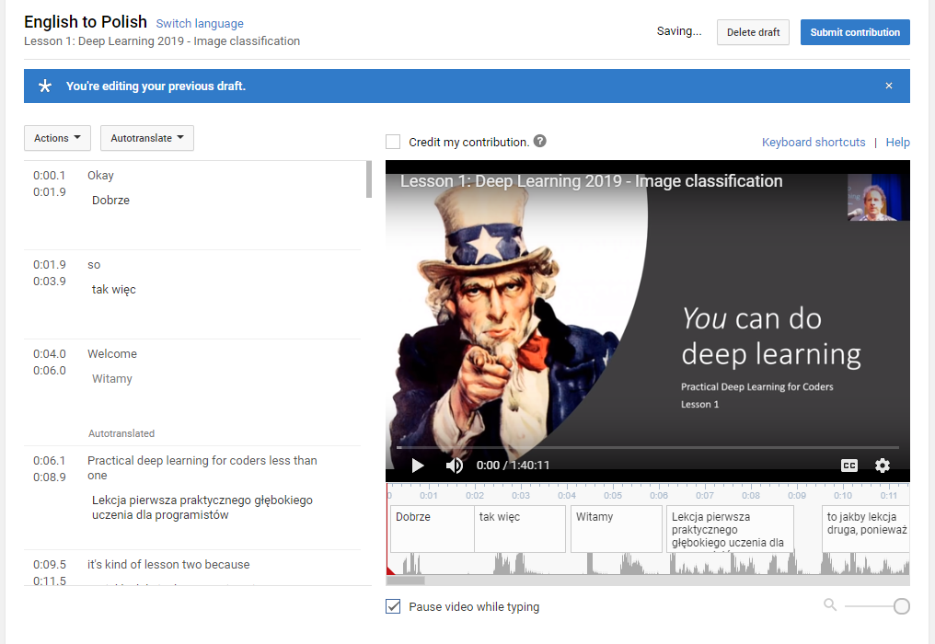
6. Option: credit my contribution



1. In the editor you can play, stop video and edit subtitles (a draft is auto saved so you can come back later to finish the translation)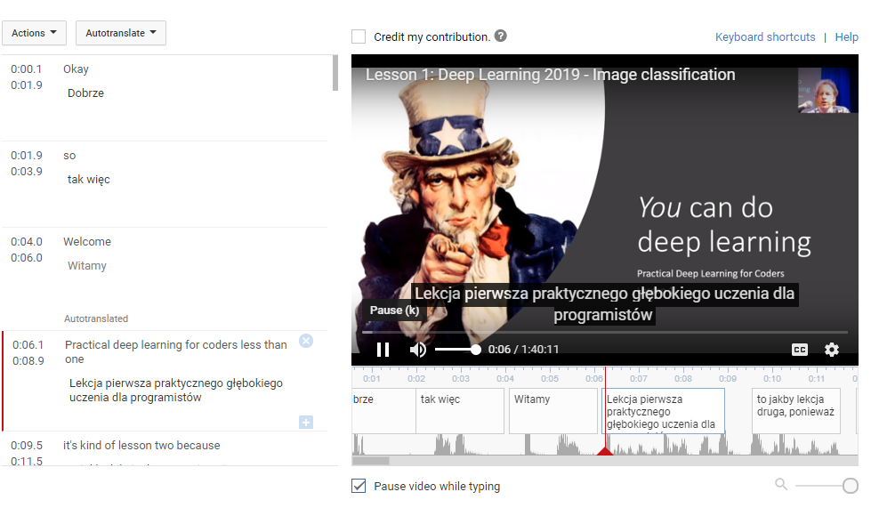
2. Once finished, submit the translation to the owner of the video for approval. Congratulations!